Hands On Session
SPRING LEARN - SPRING BOOT WEB PROJECT
Project Overview
A simple Spring Boot web project created for learning and demonstration purposes.
Group: com.cognizant
Artifact: spring-learn
Spring Boot Version: 3.2.5
Java Version: 17
Dependencies: Spring Web, Spring Boot DevTools
Steps
1. Build the Project: Open terminal and navigate to the project directory:
cd path/to/spring-learn
mvn clean package
2. Import into Eclipse :File > Import > Maven > Existing Maven Projects > Browse to the project folder > Finish
3. Run the Application :Right-click SpringLearnApplication.java > Run As > Java ApplicationThe application starts on port 8080 by default.
4. Verify Startup :Check the console for log messages like START and END and the Spring Boot banner.

Project Structure
- src/main/java - Application source code
- src/main/resources - Application configuration
- src/test/java - Test code
- pom.xml - Maven configuration

Screenshots
- SpringLearnApplication.java in Eclipse
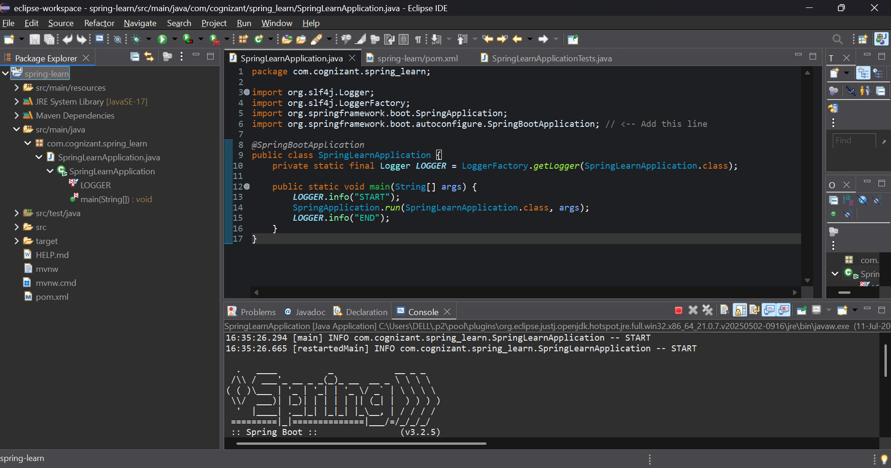
- Spring Boot Console Output
